1.



2.



3.



4.



5.

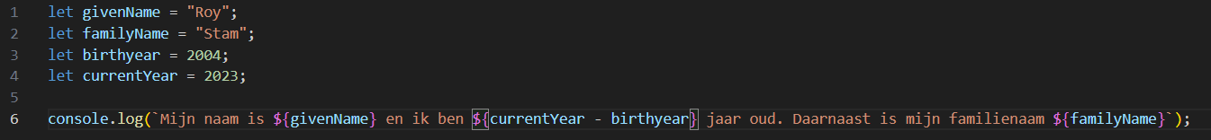



6.



7.



8.



9.

